High-level Overview
The solution based on Datamart assumes keeping the backend infrastructure in one place, creating reports based on semantic models in Power BI Service, and then maintaining the frontend in the application.
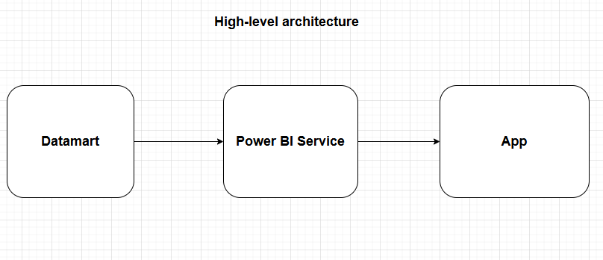

Inside Datamart, the solution assumes three-layer architecture (ETL process).
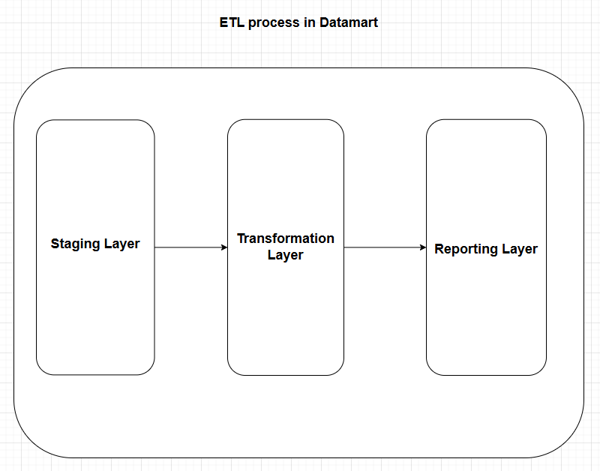
Semantic models sourced from Datamart architecture
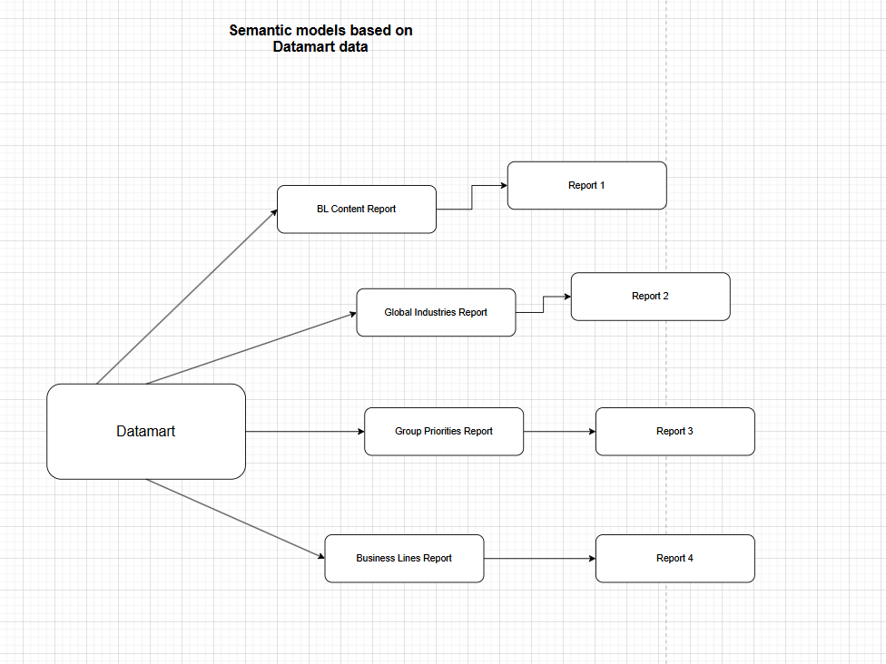

Google Analytics storage
As the reason for Datamart creation was Google Analytics storage, the GA table assumes daily incremental refresh and keeping it in a yearly chunk (example for 2025).
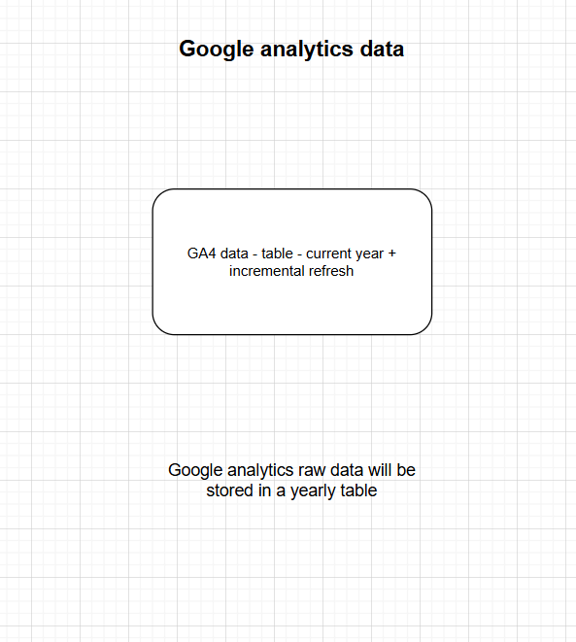

The final architectural stage assumes keeping reports in Power BI app to enable access for users.
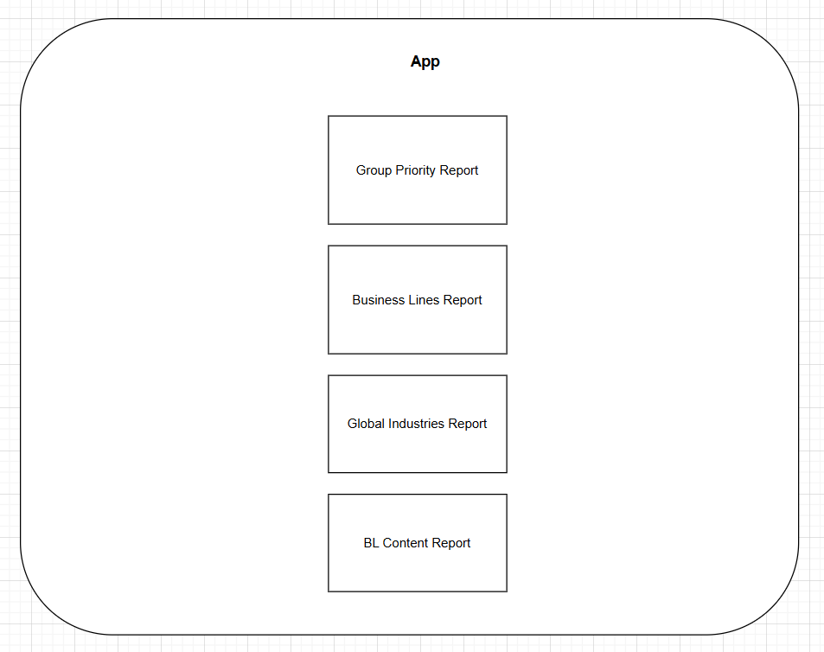

Power BI service
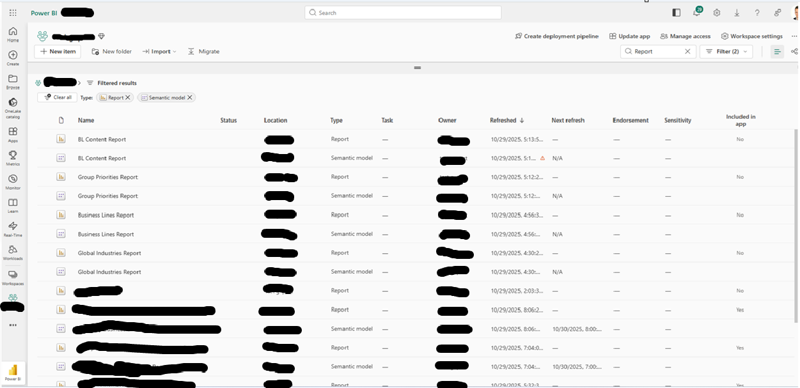
App
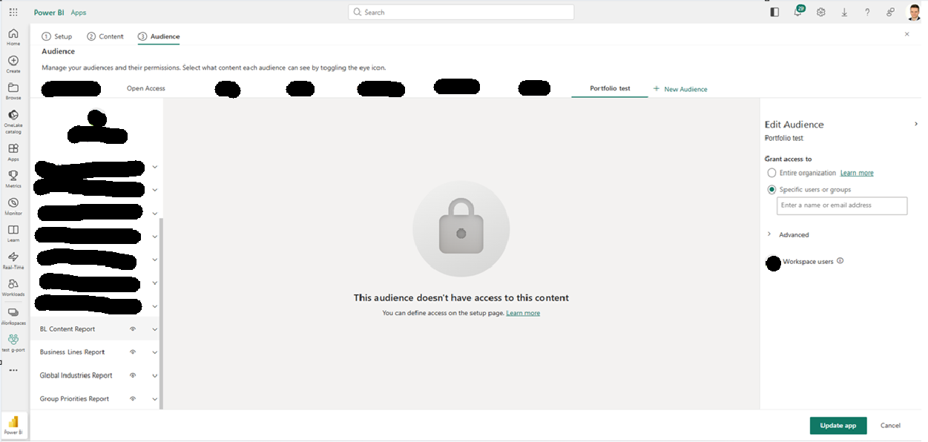

BL Content Report – Data Model
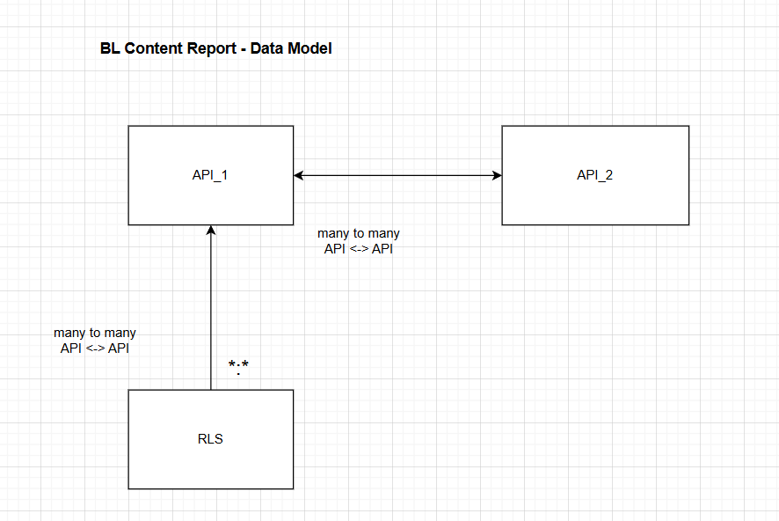

Group Priorities Report – Data Model
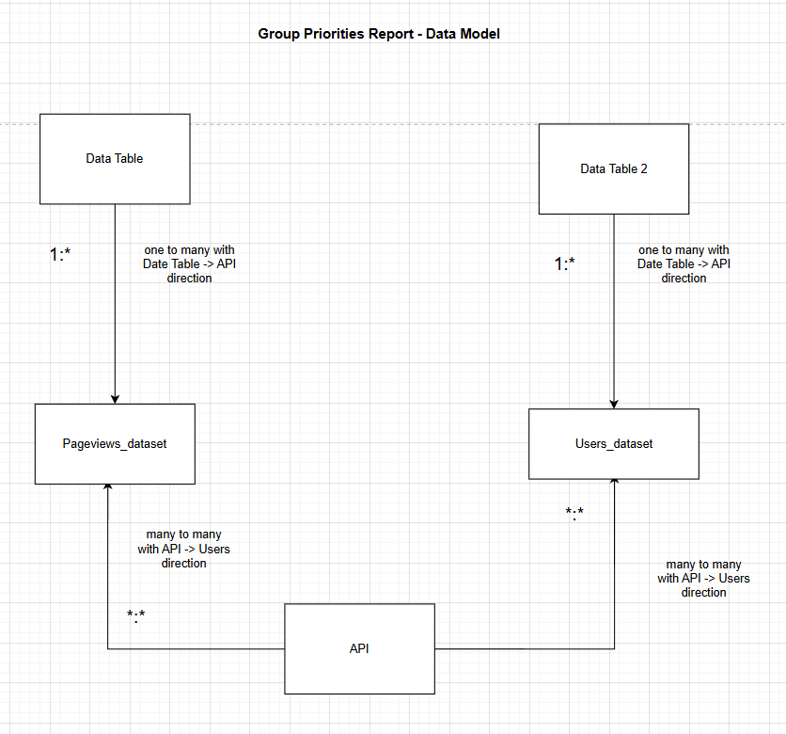

Global Industries – Data Model
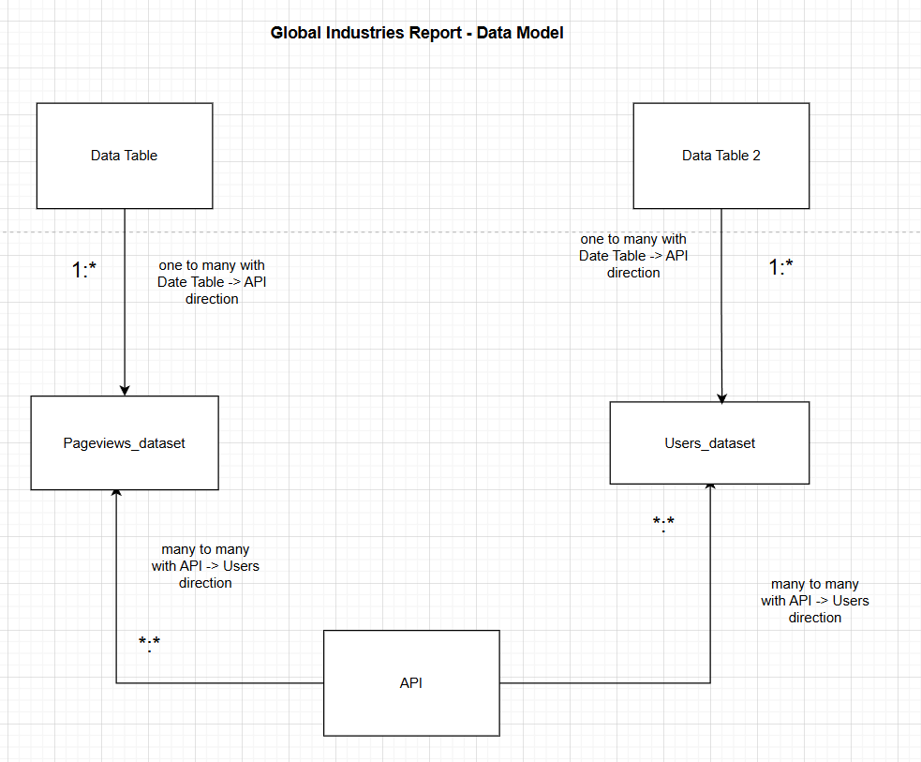

Business Lines Report - Data Model
